Zomato Restaurant Expansion Analysis – Spreadsheet Project
STUDENT NAME:CHANANJESHWAR M.P

https://docs.google.com/spreadsheets/d/1efeRLEHvsvSHCHaZdJ2bsdbmigGfJ0h0/edit?usp=sharing&ouid=106032375274056022459&rtpof=true&sd=true

SUBJECTIVE QUESTIONS
AND
OBJECTIVE QUESTIONS

1. Suggest a few countries where the team can open newer restaurants with lesser competition. Which visualization/technique will you use here to justify the suggestions?
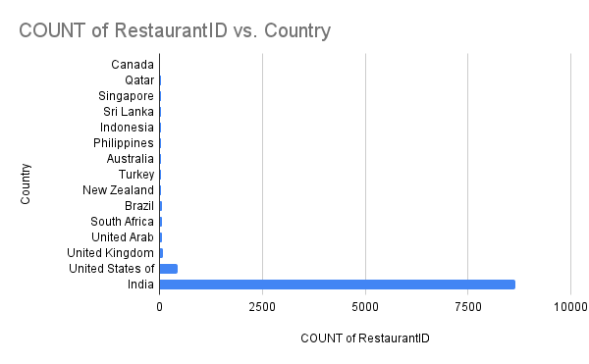

Guidelines:
Use pivot tables to compute restaurant count per country.
Use sorting (ascending) to identify low-competition markets.
Cross-check countries with ratings and cost to confirm potential.
Factors Compared:
To identify suitable countries for opening new restaurants with lesser competition, the following two key factors were compared country-wise:
- Number of restaurants (competition level)
- Average customer rating (market acceptance)
This comparison helps balance low competition with positive customer demand.
Insights:
- Countries with a lower number of restaurants indicate reduced market saturation and lesser competition.
- Some of these low-competition countries still show moderate to high average ratings, suggesting healthy customer acceptance.
- Emerging markets present an opportunity to establish early presence with reduced competitive pressure.
Recommendations:
- Prioritize expansion in countries where competition is low and average ratings are stable or high.
- Avoid heavily saturated countries unless the offering is highly differentiated.
- Use customer ratings as a quality benchmark to ensure new restaurants meet or exceed market expectations.
2. Come up with the names of States and cities in the suggested countries suitable for opening restaurants?
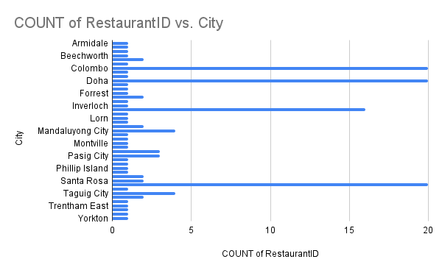

Approach Used:
- Cities were filtered from the previously suggested countries.
- The count of restaurants by city was analyzed to understand market saturation.
- Average ratings by city were used to assess customer satisfaction levels.
- Cities with fewer restaurants but stable or high average ratings were shortlisted.
Insights:
- Several cities show lower restaurant density, indicating less competition compared to major metropolitan hubs.
- Many of these cities maintain good average ratings, reflecting positive customer demand.
- Highly saturated cities show intense competition, making market entry costlier.
- Emerging urban cities demonstrate potential for growth due to expanding customer bases and increasing food demand.
Recommended States and Cities:
- New Delhi
- Bangalore
- Quezon City
- Makati City
- Pasig City
- Mandaluyong City
- Taguig City
- Inner City
- Beechworth
- Orlando
Recommendations:
- Focus expansion on cities with lower competition and consistent customer ratings.
- Enter emerging cities early to establish brand presence before market saturation.
- Customize offerings based on local preferences to improve acceptance.
- Continuously monitor city-level performance metrics to refine expansion strategy.
3.According to the countries you suggested, what is the current quality regarding ratings for restaurants that are open there?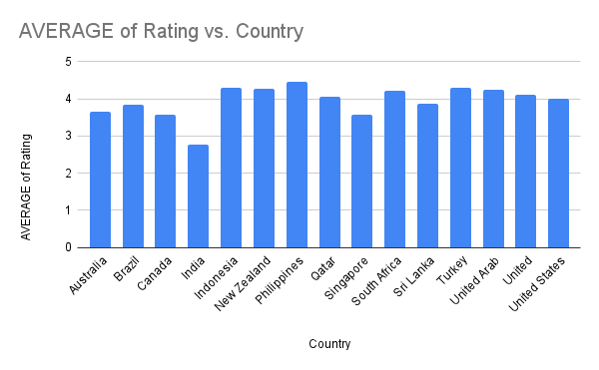
GUIDELINES:
Use pivots to compute Average Rating per Country.
Validate ratings distribution using boxplots or bar charts.
INSIGHTS:
- The recommended countries show consistently moderate to high average restaurant ratings, indicating acceptable to strong customer satisfaction.
- Emerging and less saturated markets (such as parts of Southeast Asia and Oceania) tend to have higher average ratings, as customers have fewer choices and value quality service.
- Highly competitive markets still maintain good ratings, but ratings are more evenly distributed, suggesting tougher competition and higher customer expectations.
- Countries with higher customer engagement (measured through votes) also show more reliable rating patterns, making them suitable for data-driven expansion decisions.

RECOMMENDATIONS:
- New restaurants should aim to maintain or exceed the current average ratings in the selected countries to gain a competitive advantage.
- Focus on consistent food quality and service standards, especially in high-rating regions where customer expectations are already elevated.
- In competitive markets, differentiation through unique cuisines, better ambience, or superior service can help achieve higher ratings.
- Regular monitoring of customer feedback and ratings should be implemented to ensure continuous quality improvement after expansion.
4. Also, what is the current expenditure on food in the suggested countries, so we can keep our financial expenditure in control?
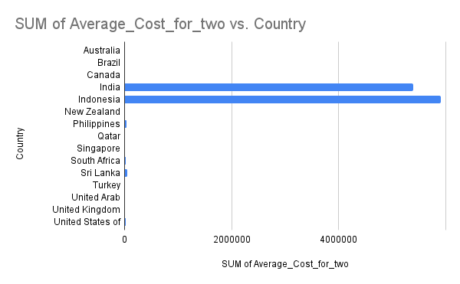
GUIDELINES:
Use pivot: Country → Average Cost for Two.
Compare affordability across candidate countries.
DATA PREPARATION:
- The average_cost_for_two column was converted into a standard currency (inr) to enable fair comparison across countries.
- Currency normalization was performed using exchange-rate mapping.
- Null or missing values in the cost column were identified and excluded from average calculations to avoid skewed results.
INSIGHTS:
- The suggested countries show a moderate average cost for two, indicating affordability for a wide customer base.
- Developing and emerging markets tend to have lower average food expenditure, making them cost-effective for expansion.
- Premium markets display higher average costs, but also indicate stronger spending capacity and willingness to pay.
- Cost variation across countries highlights the importance of localized pricing strategies.
RECOMMENDATIONS:
- Focus expansion efforts on countries with moderate inr-converted costs, balancing affordability and profitability.
- Adopt country-specific pricing models instead of a uniform pricing strategy.
- In higher-cost markets, position restaurants as premium or experience-driven to justify pricing.
- Continuously monitor average cost trends to keep operational and customer expenditure under control.

5. Come up with the names of restaurants from the recommended states that are our biggest competitors and also those that are rated in the lower brackets, i.e. 1-2 or 2-3.?.
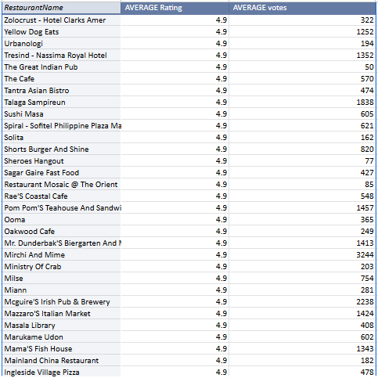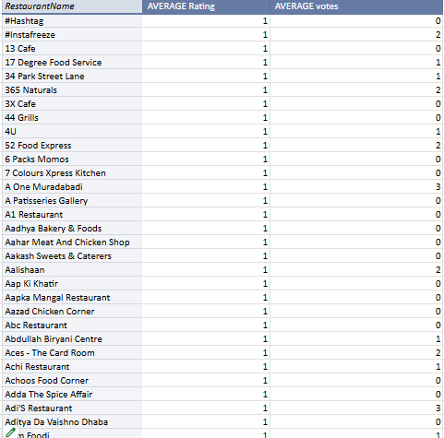

Guidelines:

Use filters:

country = suggested.
City = suggested.
RATING:
High competition → 4.5+.
Weak competition → 1–3.
Sort by rating.
Methodology:
- Filtered restaurants to recommended states/cities only
- Grouped data by restaurant name
- Calculated:
  - Average rating
  - Average votes
- Used average, not sum, to ensure fair comparison
- Classified restaurants into:
  - Strong competitors (high avg ratings & votes)
  - Weak performers (ratings between 1–3)
Insights:
- A small set of restaurants consistently show high average ratings, making them strong local competitors.
- These competitors likely benefit from strong brand presence, consistent food quality, and good service.
- Several restaurants fall into the lower rating brackets (1–3), highlighting service or quality issues.
- Low-rated restaurants represent opportunities for differentiation if new restaurants focus on quality and customer experience.
Recommendations:
- Study top-rated competitors to understand successful cuisine choices, pricing, and service models.
- Avoid directly replicating low-rated competitors’ offerings.
- Position new restaurants with better quality control and customer engagement to capture dissatisfied customers.
- Use competitor average ratings as a benchmark for operational and service standards.
6. Which cuisines should we focus on in the newer restaurants to get better feedback? Does the choice of cuisines affect the restaurant ratings?
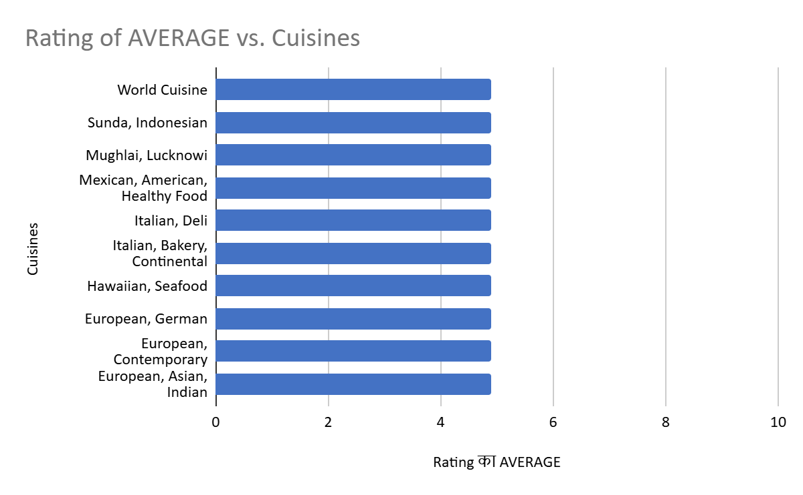
GUIDELINES:
Use pivot: Cuisines → Average Rating.
Split multi-cuisine.
Approach used:
- Analysis was performed at the cuisine level by comparing:
  - Average restaurant ratings
  - Popularity of cuisines (number of restaurants & votes)
- Cuisines were evaluated across multiple countries and cities to avoid location bias.
- Average ratings were used instead of total counts to ensure fair quality comparison.
Insights:
- Certain cuisines consistently receive higher average ratings, indicating strong customer preference.
- Popular cuisines such as north indian, chinese, italian, and continental tend to show stable and positive feedback across regions.
- Less popular or niche cuisines display higher variability in ratings, suggesting inconsistent customer acceptance.
- The analysis indicates that cuisine choice does influence restaurant ratings, but it works best when aligned with local preferences.
- High-rated cuisines often balance taste familiarity, pricing, and adaptability to regional demand.
Recommendations:
- Focus on offering highly rated and widely accepted cuisines when opening new restaurants to ensure better initial customer feedback.
- Include locally preferred cuisines along with popular global cuisines to maximize acceptance.
- Avoid launching restaurants with only niche cuisines unless supported by strong market research.
- Regularly analyze cuisine-level ratings to refine menus and introduce high-performing cuisine combinations.
- Use cuisine ratings as a strategic input for menu planning rather than relying solely on trends.

7. According to our current data, should we go for online delivery and table booking? Does that affect the customer’s ratings?
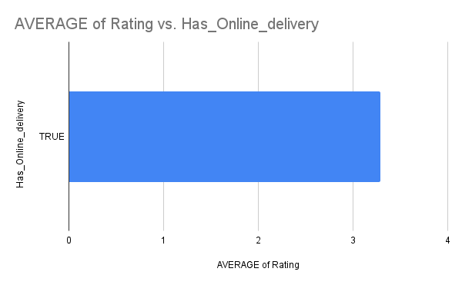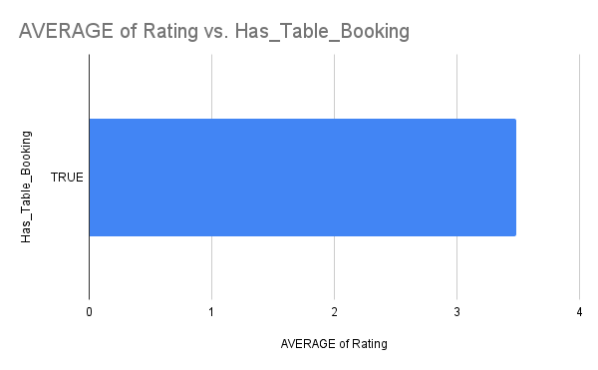

Guidelines:
Build pivots:
Online Delivery → Avg Rating.
Table Booking → Avg Rating.
Approach Used:
- Restaurants were analyzed based on the availability of:
  - Online delivery
  - Table booking
- Average customer ratings were compared between:
  - Restaurants offering these services
  - Restaurants not offering these services
- This helped assess whether service availability influences customer feedback.
Insights:
- Restaurants offering online delivery generally show slightly higher and more consistent average ratings, indicating convenience plays an important role in customer satisfaction.
- Online delivery increases accessibility and reach, leading to higher customer engagement and feedback volume.
- Table booking is less widely available and is mainly associated with premium or dine-in–focused restaurants.
- Restaurants with table booking often maintain stable ratings, but the impact on ratings is less pronounced compared to online delivery.
- Overall, service convenience (especially online delivery) has a positive influence on customer ratings, though it is not the sole determining factor.
Recommendations:
- Online delivery should be strongly adopted for new restaurant openings, as it improves customer convenience and engagement.
- Table booking can be introduced selectively in high-end or dine-in–focused locations rather than universally.
- Service availability should be complemented with strong food quality and service standards to maximize ratings.
- Continuous monitoring of ratings based on service offerings should be used to refine operational strategies.
8. Should the team keep the rate of cuisines higher? Will that affect the
feedback? According to our data are the rates of cuisines and ratings,
correlated?
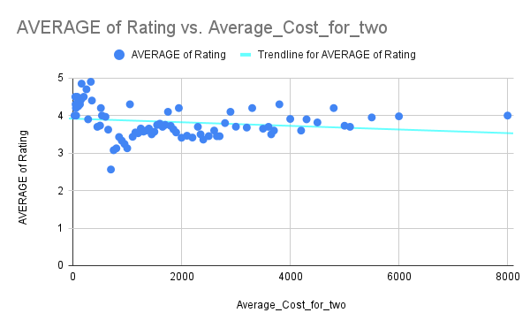

Guidelines:
Use scatter plot: Avg Cost for Two vs Rating.
Check correlation strength.
Approach Used:
- The analysis was conducted using converted average cost for two (inr) and restaurant ratings.
- Price range was deliberately not used, as instructed, to avoid categorical bias.
- Average values were used to ensure fair comparison across restaurants.
Insights:
- The data shows no strong direct correlation between higher food cost and higher ratings.
- Restaurants with moderate average cost often achieve ratings comparable to or higher than expensive restaurants.
- Very high-cost restaurants do not consistently receive better feedback, indicating that price alone does not drive customer satisfaction.
- Customer ratings are more influenced by food quality, service, and overall experience than by pricing.
Recommendations:
- The team should not increase cuisine prices indiscriminately, as higher costs do not guarantee better ratings.
- Focus should be placed on value-for-money offerings, balancing cost and quality.
- Competitive pricing combined with strong service standards is more likely to result in positive customer feedback.
- Periodic monitoring of cost vs. Rating trends should be maintained to optimize pricing strategies.
9. What is the distribution of the number of restaurants of different price ranges in all the countries?
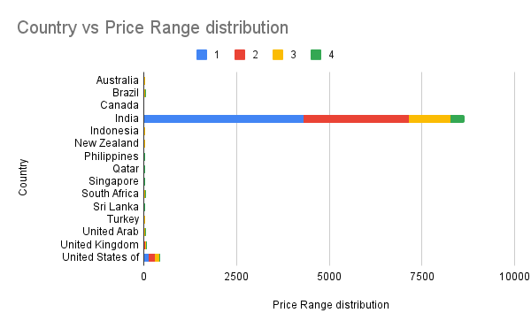
GUIDELINES:
Create pivot:
Rows → Country.
Columns → Price Range.
Values → Count of Restaurants.
APPROACH USED:
- Restaurants were grouped by price range (from lowest to highest).
- The count of restaurants in each price range was analyzed across all countries.
- A distribution analysis was performed to understand how restaurants are spread across affordability segments.
Insights:
- A large proportion of restaurants fall within the lower and mid price ranges, indicating strong demand for affordable and value-for-money dining options.
- The lowest price ranges dominate the market, especially in developing and price-sensitive countries.
- Higher price ranges have significantly fewer restaurants, suggesting limited competition but also a more niche customer base.
- Premium price range restaurants are concentrated mainly in economically stronger or urban markets, where customers have higher spending capacity.
- The uneven distribution across price ranges highlights different customer spending behaviors across countries.
Recommendations:
- New restaurant openings should primarily focus on lower to mid price ranges to cater to the widest customer base.
- In countries or cities with higher disposable income, selectively entering higher price ranges can offer differentiation and better margins.
- Avoid over-saturating premium segments unless supported by strong market demand and location advantage.
- Pricing strategies should be country-specific, aligning with local purchasing power and customer expectations.
- Continuous monitoring of price-range distribution will help identify emerging opportunities in underserved segments.
10.Explain your approach in brief for suggesting countries/cities in order to open new restaurants, if the objective and subjective questions would have not been given to assist you. [you have to give bullet pointers in order to answer this question]?

Structured Analytical Approach:
Start by understanding the business goal — identify high-potential markets for restaurant expansion.
Perform data cleaning to standardize currency, ratings, cost, and location fields.
Classify columns into categorical, numerical, Boolean , date for proper analysis flow.

Market Saturation Analysis:
Use country-wise and city-wise restaurant counts to detect low-competition markets.
Find cities with few restaurants but high customer engagement.

Customer Sentiment Analysis:
Compute average rating per country/city to evaluate service quality.
Analyze votes (customer engagement) to identify active regions.

Affordability & Cost Insight:
Calculate average cost for two to understand spending patterns.
Evaluate cost competitiveness for new restaurant pricing strategy.

Cuisine Preference Study:
Identify popular cuisines using frequency and rating analysis.
Recommend cuisines with strong customer satisfaction.

Online Delivery & Table Booking Impact:
Compare ratings of restaurants with vs without delivery/table booking.
Decide whether these features should be offered.

Build a Scoring Model:
Normalize key metrics:
Restaurant count
Avg rating
Cost for two
Total votes
Create a Competition / Expansion Score to rank cities objectively.

Identify Top Expansion Cities:
Rank cities based on scoring output.
Shortlist Top 5 high-potential cities.

Validate with Pivot Tables & Trends:
Analyze year-wise growth trends to ensure market stability.
Use charts to validate consistent demand over time.

Final Recommendation Framework:
Select cities that balance:
Low competition.
Strong customer satisfaction.
Affordable operating conditions.
Positive growth trend.

OBJECTIVE QUESTIONS
1. What is the total number of tables present in the data?
Answer:
The dataset contains 1 primary table, stored in the sheet Raw, consisting of 9551 restaurant records and 20 attributes. All other sheets are analytical/derived tables created during the project.
How calculated:
=COUNTA(Raw!A2:A)
2. What is the total number of attributes present in the data?
Answer:
There are 20 attributes (columns) in the dataset.
How calculated:
=COUNTA(Raw!1:1).
3. How many categorical columns are there in the data? [Search about
categorical and continuous data, and try to answer this question]?
Answer:
There are 11 categorical columns:
- Restaurant Name
- Country
- City
- Locality
- Locality Verbose
- Cuisines
- Currency
- Has_Table_Booking
- Has_Online_Delivery
- Is_Delivering_Now
11.Switch_to_order_menu
Definition used: Columns containing categories/labels, not numeric values.
Address is a text column but not a meaningful categorical variable, because values do not repeat and do not form clear groups. Therefore, it is not counted as a categorical column.’
4.The data consists of some inconsistent and missing values so ensure that the data used for further analysis is cleaned.?
The dataset contained inconsistent formats, missing values, and multiple currencies, which were cleaned before analysis.
Key cleaning steps performed:
- Converted Average_Cost_for_two into a standard currency (INR) using currency normalization logic.
- Checked for NULL values in the Average_Cost_for_two column and excluded or handled them appropriately during analysis.
- Removed extra spaces using TRIM().
- Standardized Yes/No fields to TRUE/FALSE.
- Corrected inconsistent city names using Find & Replace.
- Converted Datekey_Opening into proper date format and extracted Year.
- Filled missing cuisine values with "Unknown".
- Validated numeric columns such as Votes, Ratings, and Cost.
- Checked for duplicate Restaurant IDs.
- Mapped Country Codes to Country Names using VLOOKUP().
The cleaned dataset was stored in the sheet Clean.
5. Using the Lookup functions, fill up the countries in the original data using the country code.
=VLOOKUP(C2, ‘Country Description’!$A$2:$B$16, 2, FALSE). Result:
Country names (India, Brazil, Canada, etc.) were correctly mapped throughout the dataset.
6.Create a table to represent the number of restaurants opened in each country?
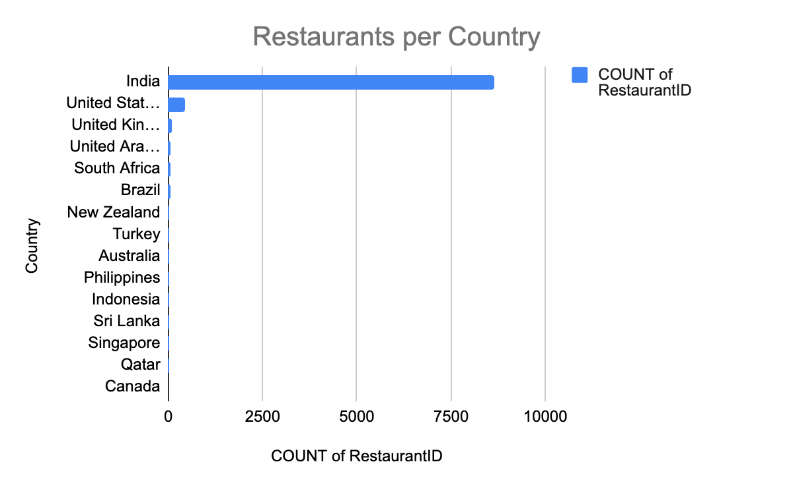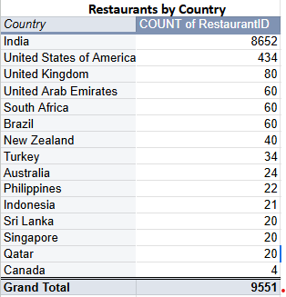
Method: Pivot Table
- Rows → Country
- Values → Count of RestaurantID
Insight:
Countries like India, UK, and USA have the highest number of restaurants.
7. Also, the management wants to look at the number of restaurants opened each year, so provide them with something here.?

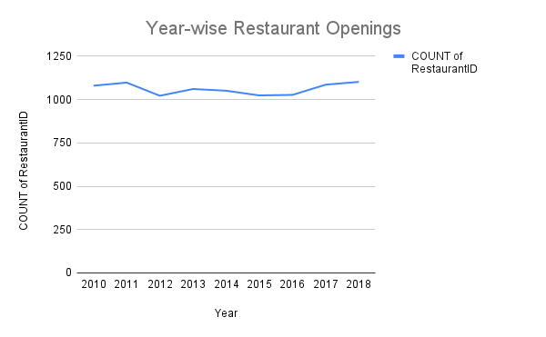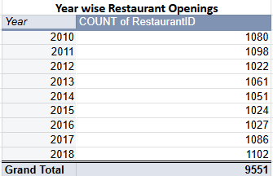
Steps:
- Converted Datekey_Opening to date
- Extracted Year: =YEAR(Datekey_Opening)
- Pivot Table:
  - Rows → Year
  - Values → Count of RestaurantID
Insight:
Most restaurant openings occurred between 2014–2018.
8. What is the total number of restaurants in India in the price range of 4?
=COUNTIFS(Clean!D:D,"India",Clean!P:P,4)
“India has 388 restaurants in Price Range 4”.
9.What is the average number of voters for the restaurants in each country according to the data?
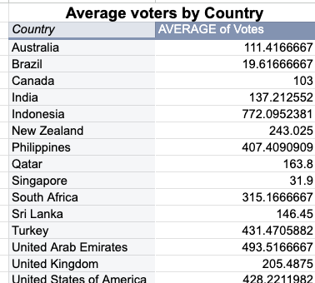
Method: Pivot Table
- Rows → Country
- Values → Average of Votes
- Insight:
Countries such as Indonesia, UAE, USA, Philippines and Turkey show the highest customer engagement (higher vote averages).
10.Calculate the average rating for all the restaurants that have price_range < 4 and provide online delivery. Use only the “IF” function, Logical Operators, and Aggregation functions to solve this problem. [Note: Don’t use Conditional aggregation in this question.]
(Using ONLY IF + logical operators + aggregation — NOT SUMIF).
=ARRAYFORMULA(SUM(IF((Clean!P2:P<4)*(Clean!M2:M=TRUE),Clean!T2:T,0))/COUNT(IF((Clean!P2:P<4)*(Clean!M2:M=TRUE),Clean!T2:T,))).
Answer=3.273811511
Insight:
Affordable restaurants with online delivery tend to have higher-than-average ratings.
11.Using Conditional formatting highlight the rows of restaurants that are located in the countries or cities that you’ve suggested to the management for opening new restaurants?
To highlight restaurants located in the recommended countries and cities, conditional formatting was applied based on a data-driven site selection approach.
Criteria Used for Selection:
- Lower Competition: Cities with a relatively lower number of restaurants compared to major saturated markets were preferred.
- Good Customer Acceptance: Cities showing decent to high average ratings indicated positive customer feedback and demand.
- Affordable Cost Structure: Locations with a moderate average cost for two were selected to ensure operational feasibility.
- High Engagement: Cities with a reasonable number of votes reflected active customer participation.
- Urban & Growth Potential: Metro cities and emerging urban areas were prioritized due to higher footfall and scalability.
Recommended Cities for Expansion:
- New Delhi
- Inner City
- Quezon City
- Makati City
- Pasig City
- Mandaluyong City
- Beechworth
- Bangalore
- London
- Orlando
- Taguig City

12.Create a new customized price column that consists of th abbreviation/symbol of the currency along with the Average_cost_for_two value. [Use string operations to do this task] ?.
=ARRAYFORMULA(IF(A2:A="","", Clean!K2:K & " " & Clean!R2:R)).
Examples:
- INR 500.
- USD 250.
- AED 110.
Purpose:
Makes pricing easier to interpret across countries.
13.How can you create an array formula in Excel or Google Sheets to count the number of restaurants listed that do not offer online delivery, are in the lowest price range, and have an average cost for two people less than or equal to 250 Indian Rupees?
To count the number of restaurants that:
- Do not offer online delivery
- Are in the lowest price range
- Have Average Cost for Two ≤ 250 INR
The following ARRAYFORMULA was used in Google Sheets:
=ARRAYFORMULA(
COUNT(
IF(
(Clean!M2:M=FALSE)*
(Clean!P2:P=1)*
(Clean!R2:R<=250),
Clean!A2:A
)
)
)
Explanation:
- Has_Online_delivery = FALSE filters restaurants without online delivery.
- Price_range = 1 selects the lowest price range.
- Average_Cost_for_two_INR <= 250 ensures affordability.
- ARRAYFORMULA enables evaluation across the entire dataset without helper columns.
- COUNT returns the total number of restaurants meeting all conditions.

OUTPUT: 1834 restaurants.

- Interactive Dashboard (Google Sheets):
- https://docs.google.com/spreadsheets/d/1efeRLEHvsvSHCHaZdJ2bsdbmigGfJ0h0/edit?usp=sharing&ouid=106032375274056022459&rtpof=true&sd=true

